1.72: The eastward displacement of Manhattan from Lincoln is

and the northward displacement is

(A negative northward displacement is a southward displacement, as indicated in Fig. (1.33). Extra figures have been kept in the intermediate calculations.)

a) 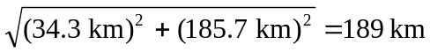

- The direction from Lincoln to Manhattan, relative to the north, is

arctan 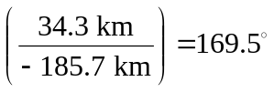

and so the direction to fly in order to return to Lincoln is 

